**User Survey Analysis**

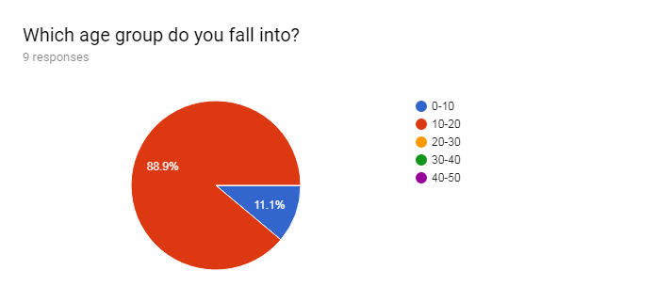

The majority of my users are within the age group of 10-20 year olds, so my website will pertain to them rather than say children or the elderly. This means that text sizes shouldn’t be too small and there should still be enough colour and such to keep users attracted to the website.

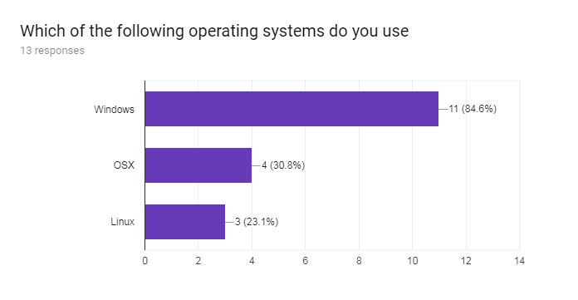

As the majority of my users use the windows operating system I will be building my website for the windows operating system as it pertains to the widest audience. Mac OSX and Linux are somewhat popular but nowhere near the level of Windows.

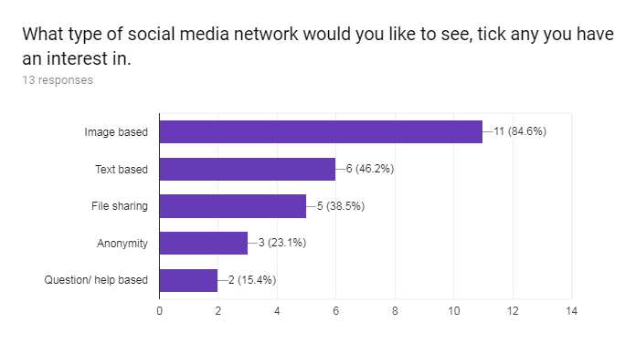

I will not be able to implement an image based social media website due to the complexity of data storage and the handling of the image between the html to the server to the sql. The site will be text based, which is the second highest feature voted for, it will however still contain some images, used for a users profile picture, banner and logo for the website.

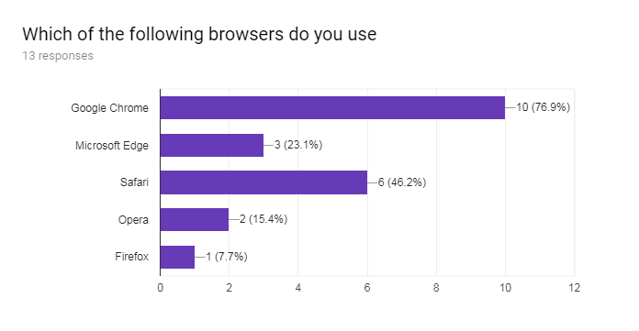

Google Chrome and Safari are the most notable web browsers. However, as I will be developing my website for windows pc's I will be ignoring Safari as Google Chrome is used more on windows computers than Safari is and as such will lead me to have a have a wider pool of potential users.

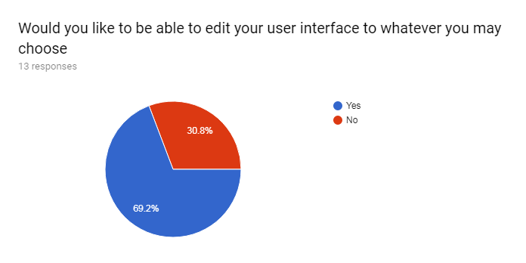

I will not be implementing this feature due to the complexity and time required for it to be implemented will be too great.

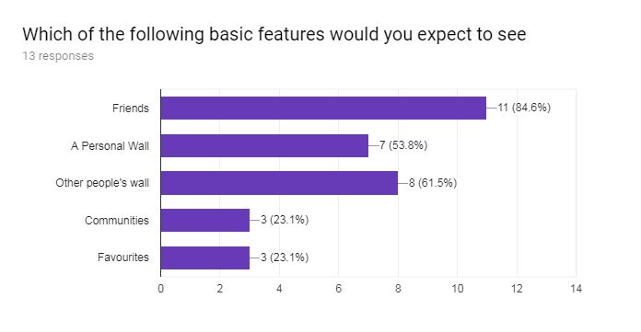

I will not be able to implement a friends feature in the time I have for the implementation due to the difficulty in making it happen. A personal wall and the ability to see other people's wall was implemented. Communities and favourites were ignored

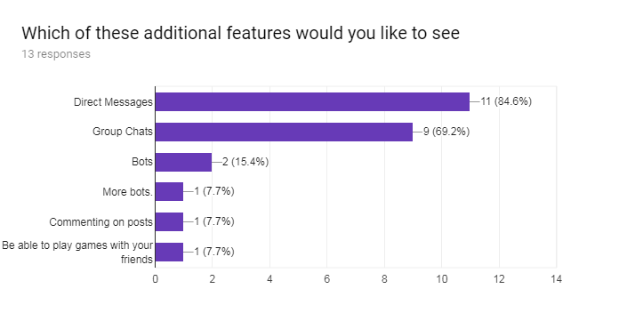

People really want to have direct messages and group chats so I will try and make them available to users. Others were not voted for much only having one or two votes so I am unlikely to be implementing them but will do if there is time.

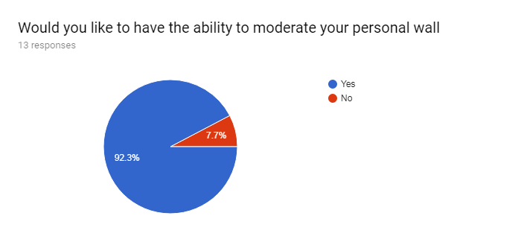

You will not be able to moderate your personal wall due to there not being enough time to implement this feature.

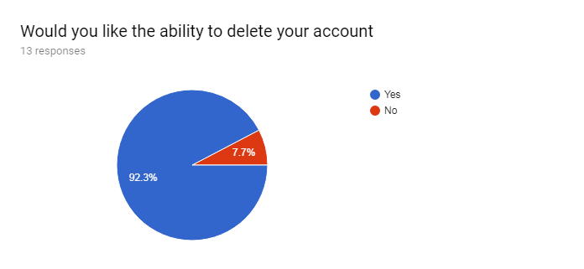

People really want the ability to delete their accounts so I will be adding this feature.

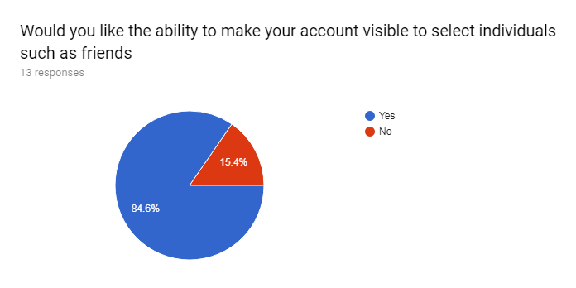

This feature was not implemented due to time constraints

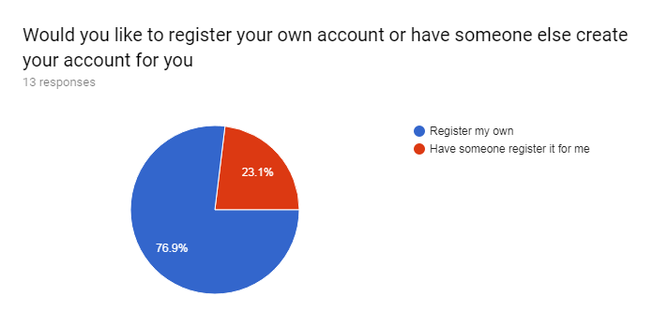

Most people want to the ability to register their own account so I will add this feature into my project.

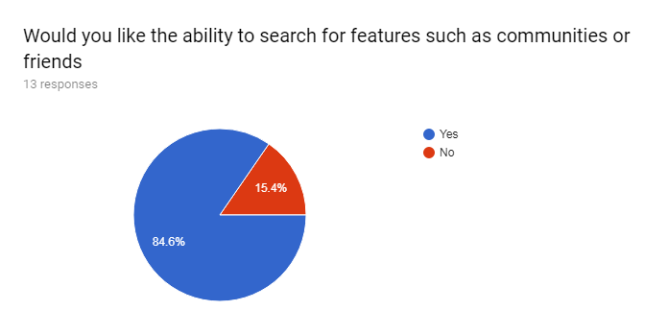

You are not able to search for friends or communities as these features were not implemented. However, you are able to search for other users and then go onto those user’s personal walls.

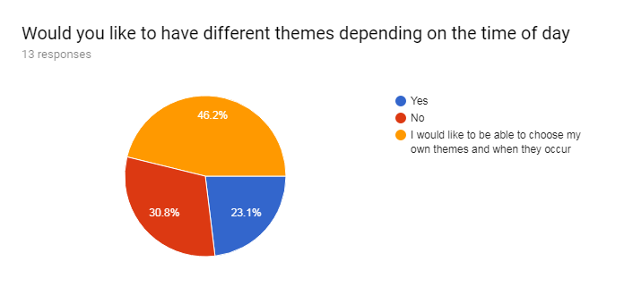

Themes will not be included in the website due to the lack of time available to implement them. This will please ~31% of users who took the poll though so not all is bad.

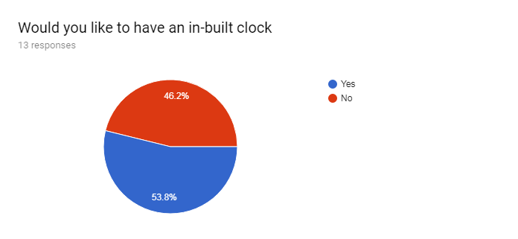

The inbuilt clock feature was omitted after input from a friend which said that there is already an inbuilt clock in the OS so why do you need an inbuilt clock in the website. This allowed me more time to focus on other features.

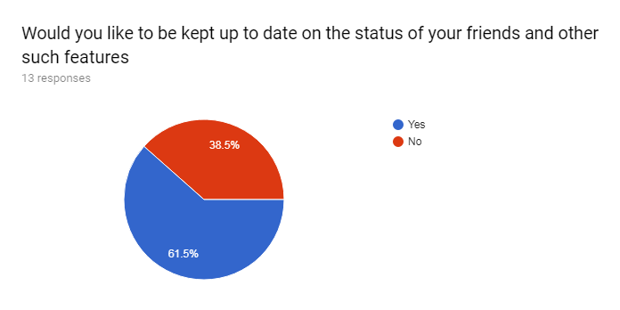

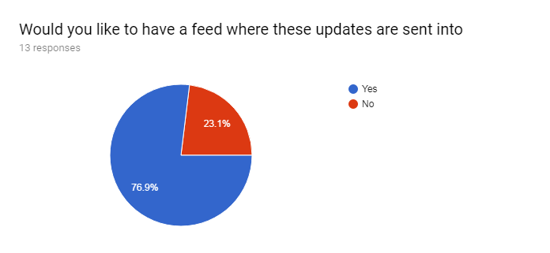People do want to be kept up to date on the status of their friends and other such features so I will create a feed which includes the post of others. However, as friends will not be implemented, the feed will now be a super feed of sorts which displays the posts of all users who post on the site. This feed will be updated each time the page is refreshed.

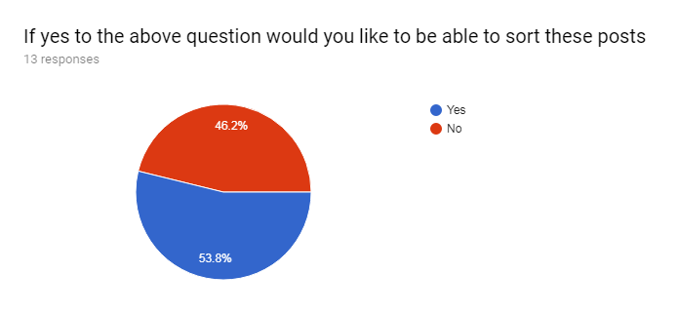

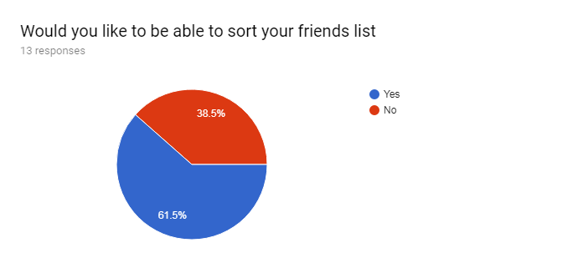

A majority of people would like to sort posts so I will include this as a feature. Surprisingly quite a few people also did not want to sort their feed so there will be a default sort that will only change when a user actively goes to change it.

As there is not enough time in the given time frame to implement friends, the ability to sort your friends list is not a feature that the website will have

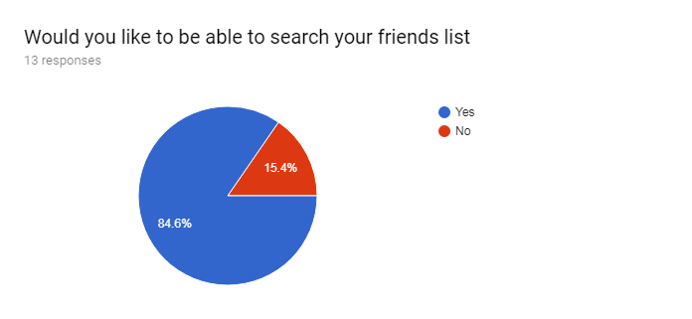

The friends list will not be implemented as such you will not be able to search your friends list. The friends list was not implemented due to time constraints and the difficulty in its implementation. You will however, be able to search for other users.

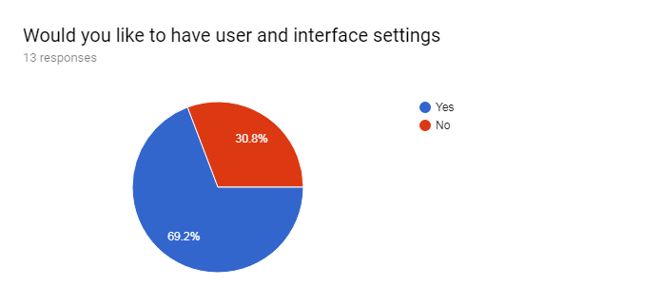

User settings will implemented but interface settings will not be due to complexity of implementation and time constraints.

| **Are there any features you would like to suggest?** |
| --- |
| 7 responses |
| Even more bots. |
| Ignore all other parts of this vote. I wanted to suggest adding formatting (bold, italics, strike-through, underlined, etc), coloured text, and LaTeX to this. |
| No |
| You should be able to communicate to all the users on the network. This may be useful for notifying users of updates. Also, you should be able to moderate public posts and block users posting inappropriate content |
| A games page which links to games websites |
| No suggestions |
| maps to see where friends be- like snapmaps |

* One of these suggestions is a joke suggestion so I will ignore that one
* Two people have no suggestions
* One would like to include their own formatting for their page and Latex. Formatting is doable but I'm unsure about LaTeX. This unlikely to be added as I don’t really know how to go about making it. However it is interesting so I will look into it and give it an attempt if time allows.
* I believe that the 4th suggested feature is for admins. I don’t think I will have the time to give some users some rights while not giving others them. Again if time allows I will attempt this however it is unlikely to be implemented.
* A games page does indeed sound interesting but I will not be adding it as I believe it may take up a lot of time.
* Maps to see where friends are will not be implemented as there are quite a few things that I will have to deal with if it was an option. Such as the GDPR as I will be holding personal data of users. Or how I would be tracking users. Whether they consent to me holding their data etc.